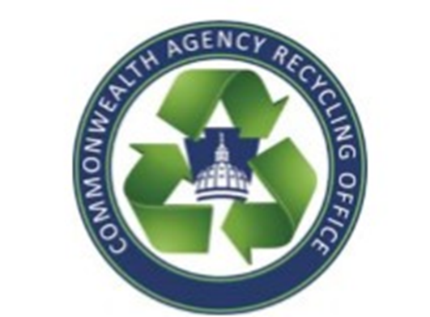
Commonwealth Agency Recycling Office
Paper Recycling Guide
RA-caro@pa.gov (717-772-2300)

Recyclable (Paper)
Office paper
Card stock
Ledger paper

Recyclable (Mixed paper): please keep mixed paper separate from your regular paper.
Glossy paper, brochures, newspaper, magazines, books, colored paper

Recyclable (Cardboard)
Corrugated boxes
Non-corrugated boxes (cereal box)
Manila folders

Non-recyclable (Trash)
Food & food wrappers
Brown expandable folders
Laminated paper
Plastic or Tyvek envelopes
Vinyl binders
Padded envelopes
Books or tablets with wire binding
Napkins
Paper plates and paper cups
Milk cartons, wax paper, coffee filters
Hanging file folders
Goldenrod envelopes
Kraft paper

