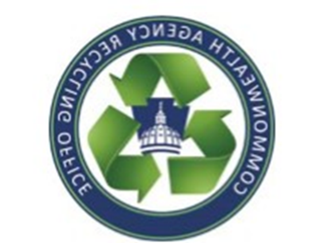
Commonwealth Agency Recycling Office
Paper Shredding & Secure Destruction Recycling Guide
RA-caro@pa.gov (717-772-2300)

Locations in the Harrisburg area should utilize the Off-site Document Shredding Services contract (4400025558). This contract provides off-site document shredding services to all agencies located within the Capitol Complex and surrounding area.

The Department of Revenue located at 1854 Brookwood Street and the Department of Transportation located at 905 Elmerton should utilized the Secure Document Destruction contract (4400025206). This contract is to provide timely, total destruction of all secured documents in accordance with IRS guidelines.

Agencies in need of secure destruction of hard drives, tapes, CDs, discs, uniforms, or any devices that contain sensitive information that cannot be wiped or degaussed, please contact CARO: 717-772-2300 or RA-caro@pa.gov.

