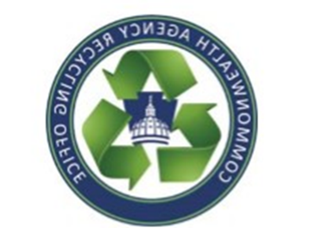
Commonwealth Agency Recycling Office
Scrap Metal Recycling Guide
RA-caro@pa.gov (717-772-2300)

Below is the current list of scrap metal vendors on contract. For more details, please refer to the Scrap Metal Removal & Recycling contract (4400023515).

SUPPLIER | SUPPLIER MAILING ADDRESS | CONTACT | PHONE # | EMAIL ADDRESS
Brookman Auto Parts Inc. | 4 Race St., Washington, PA 15301-5345 | Rodney Brookman | 724-222-4260 | info@brookmanim.com
Cresson | 134 Pfeister Ave., PO Box 187, Cresson, PA 16630 | Tom McCabe | 814-886-8143 | tmccabe@jennmar.com
Direkt Recovery | 29 Frosty Valley Rd., Bloomsburg, PA 17815 | Brant Arnold | 570-380-1317 | brant.arnold@direktrecovery.com
DMS Shredding | 400 Mill St., Dunmore, PA 18512 | Tricia Toolan | 570-346-7673 | tricia.toolan@denaples.com
Lincoln Recycling | 1602 Selinger Ave., Erie, PA 16505 | Jeremy Lincoln | 814-838-7628 | jlincoln@lincolnrecycling.com
Modern Recycling | PO Box 132, Eagleville, PA 19408 | Tiffany Lanigan | 621-721-7828 | precycleservice@aol.com
Putman Brothers | 334 East Main St., Stoystown, PA 15563 | Mark Putman | 814-893-1353 | putmanbrothers@hotmail.com
Ridge Metals | 407 Alan Wood Road, Conshohocken, PA 19428 | Rebecca Greller | 215-624-6526 | rmgreller@morrisonironandsteel.com
Special T Metals | PO Box 68, Uniontown, PA 15401 | Darryl Husenits | 724-562-8194 | dmhusenits@gmail.com
Tri-State Scrap | 2209 North 7th St., Harrisburg, PA 17110 | Dave Morris | 717-233-5606 | Tristatescrap1@gmail.com

