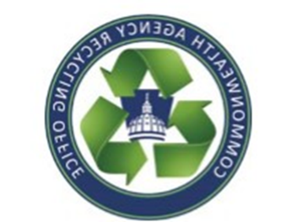
Commonwealth Agency Recycling Office
Battery Recycling Guide
RA-caro@pa.gov (717-772-2300)

LEAD ACID BATTERIES
- Examples include:
  - Car or truck batteries
  - Heavy block batteries used in Uninterrupted Power Sources (UPS) and fixed emergency lights with small tabs for connecting terminals.
- Whether sealed or unsealed, lead acid batteries have scrap value.
- All auto and truck batteries from vehicles serviced by state-managed garages should be returned for credit with the purchase of new batteries from the auto parts supply contract.
- In the Harrisburg area, DGS will collect lead acid batteries and recycle them.
- Outside of Harrisburg, lead acid batteries can go the scrap yard. Agencies should utilize the STD-497 form, so funding is allocated back to your agency.
RECHARGEABLE BATTERIES
- Nickel-Cadmium and Lithium-ion
- Examples include batteries from laptops, phones, power tools.
- Much like lead acid batteries, rechargeable batteries hold scrap value and can go to any scrap yard.
- In the Harrisburg area, DGS will collect lead acid batteries and recycle them.
- Outside of the Harrisburg area: In addition to scrap yards, rechargeable batteries can be taken to locations such as Home Depot, Lowe’s and Staples.
ALKALINE BATTERIES
- These are not hazardous waste and can be disposed of with everyday trash.
- In Harrisburg, alkaline batteries are collected by the agencies and taken to a recycler by CARO.
- Outside of Harrisburg, if you collect batteries for recycling, be prepared to pay up to $0.50/ lb.
- Please do not bring your batteries from home. Commonwealth-used batteries only.

To request a pick-up in the Harrisburg area, contact CARO: 717-772-2300

