Common Errors with SAP Purchasing Requisitions that Prevent Flow to SRM

Please make sure the following fields in the purchase requisitions are blank:
- Agreement and line item number
- Fixed Vendor
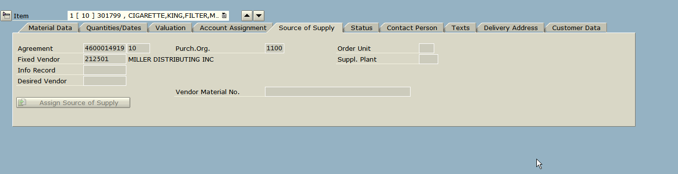

- Also, any line with a deleted material will cause the purchase requisition to error out

