Locating and Responding to a Solicitation
Locating a Solicitation
- Open your web browser and go to www.pasupplierportal.state.pa.us. Please note the important information regarding compatible browsers for the PA Supplier Portal website.
- Select the Log on button at the top right of the page.
- Enter the User ID and Password you created when you registered as a supplier and log on. If you are unable to log in, please call the Help Desk at (877) 435-7363 and selection Option #1.
- Choose the Bidder tab to begin. If you do not see a Bidder tab, another person at your company with separate log-in credentials may have been assigned the Bidder role.
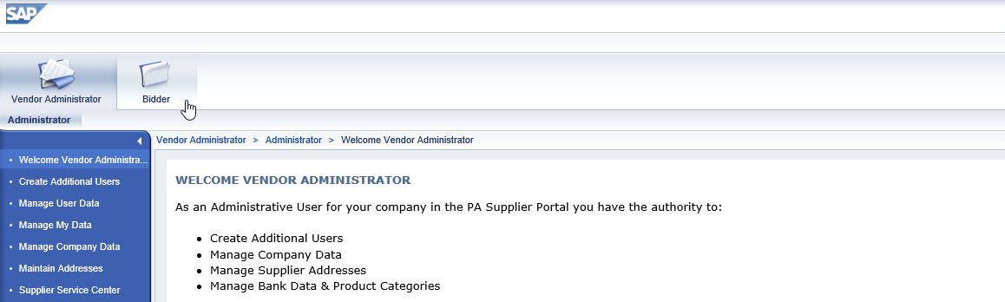
- The Bid Processing screen will open and will display all Events currently open for responses. If the search fields seen below are not visible, select the Search Criteria button to display them.
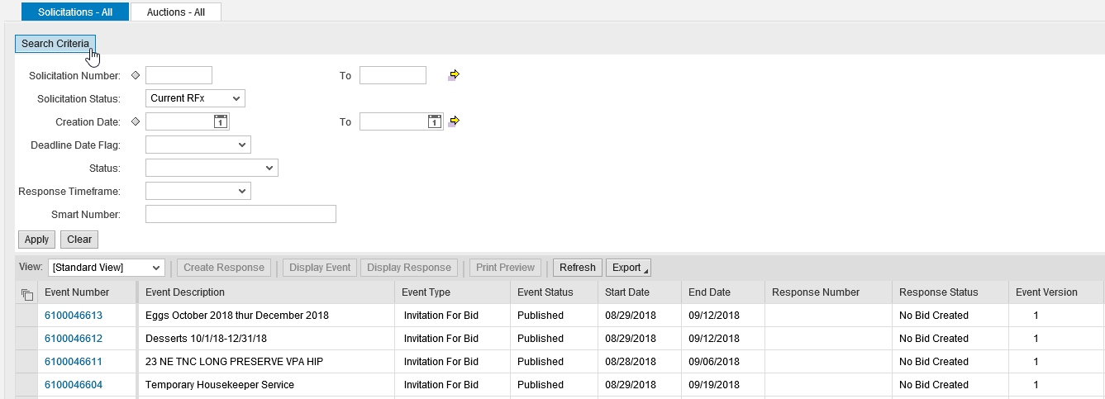
- To search for and respond to a specific Solicitation, enter the Solicitation Number in the appropriate field and select the Apply button. The Solicitation will appear below. Please ensure all fields below “Solicitation Status” are blank, as extra information such as “Status” or “Response Timeframe” may cause the system to skip over the desired Solicitation.

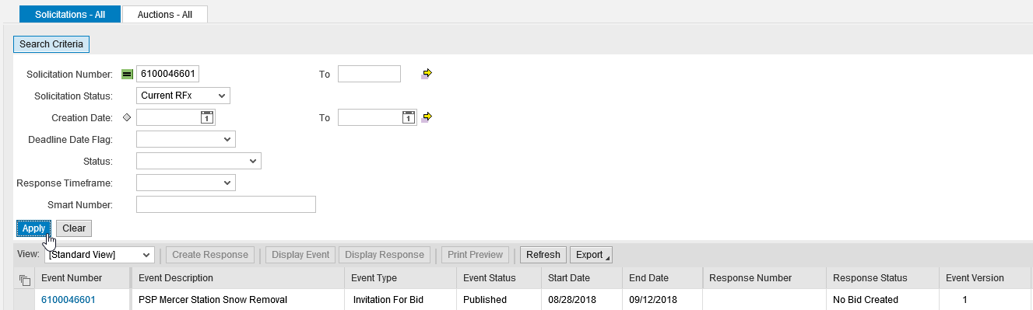

- Click the blue Event Number link to open the Solicitation in a new window. If your browser asks to allow pop-ups, select “Always Allow”. If the window still does not open, ensure all pop-up blockers are disabled.
Viewing and Responding to a Solicitation
Before creating a response, browse the Header and Items tabs for bid information.
- If you have not downloaded any bid documents, they can be found under the Header tab in the Notes and Attachments section. A description for the Solicitation can be found at the Tendering Text link. Any questions about the attachments or description can be directed to the Solicitation Owner.
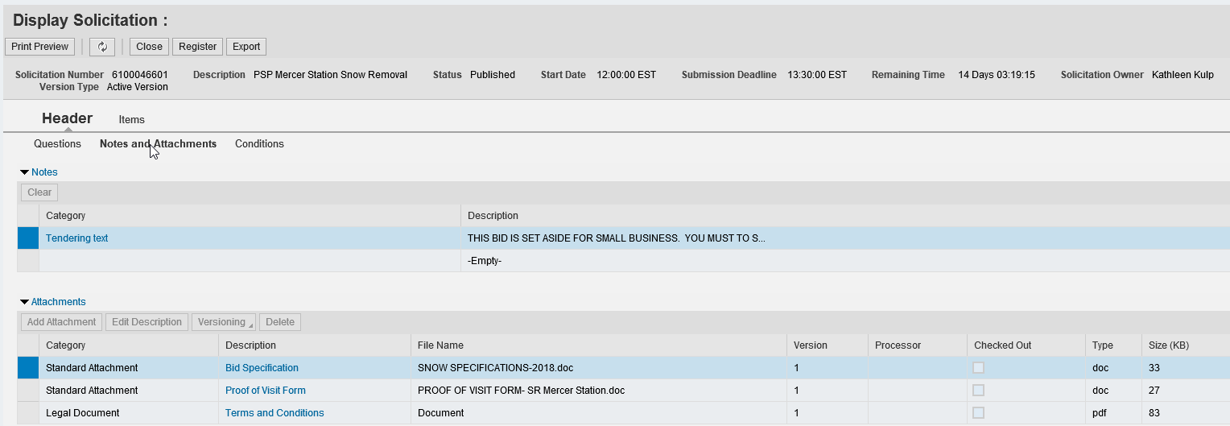
- Download all required attachments (if necessary) by clicking the linked Description of each one. It is highly recommended that you download and complete all required documents before creating a response.

- To begin your response, select Register to register your company for any potential change notices, then select the Create Response button.
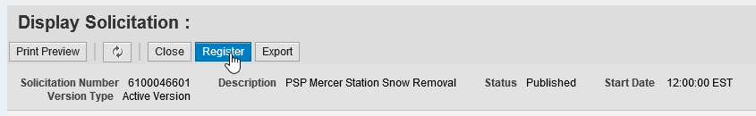
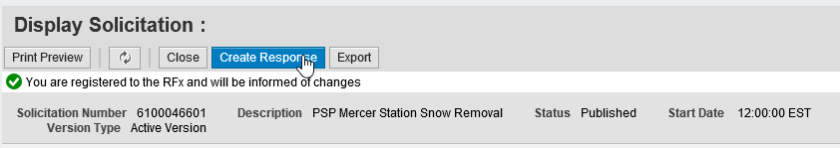
- A new Create Response window will open (see below). To complete your response, a maximum of three steps must be completed before submitting. These can be done in any order.
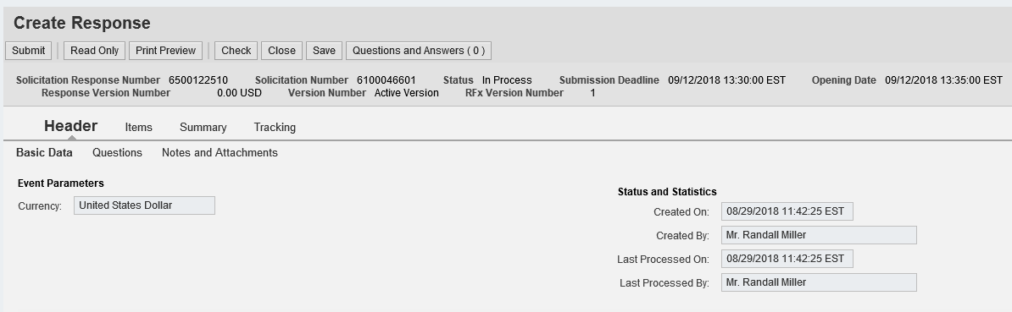
- Under the default Header tab, select Questions to answer two mandatory questions. Select “Yes” from the Reply drop-down menu on each one to indicate that you have read and understood the listed attachments.
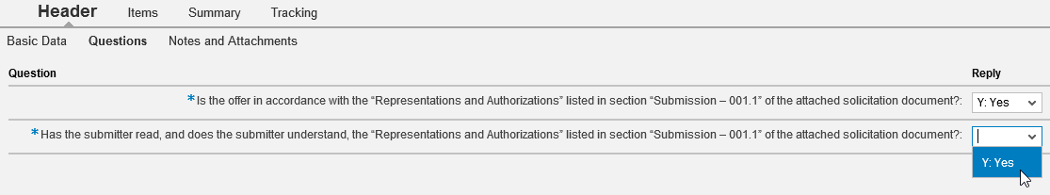

- Under the Header tab section Notes and Attachments, select the Header Bidder’s Remarks link to add any additional notes or select the Add Attachment button (highlighted below) to add any additional documents.
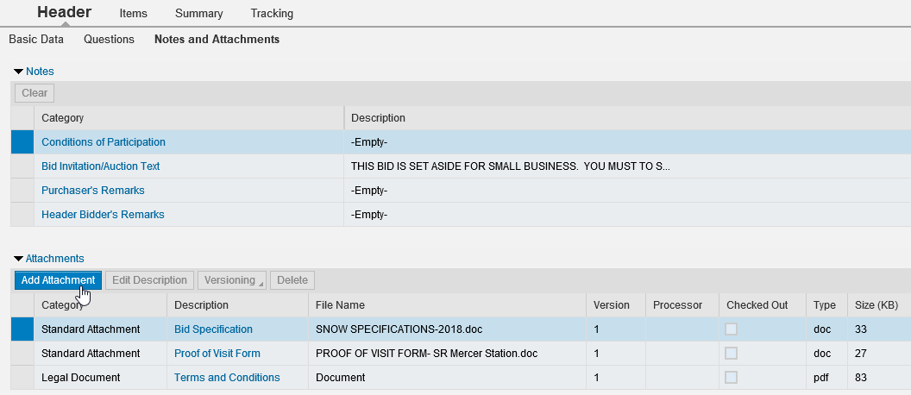
- When the Add Attachment window pops up, select Browse to search your computer for a completed attachment, open the file, and click “OK” to add it to the list (see below). If you have more than one completed attachment to add, repeat this step as necessary. If no attachments are required, skip this step.
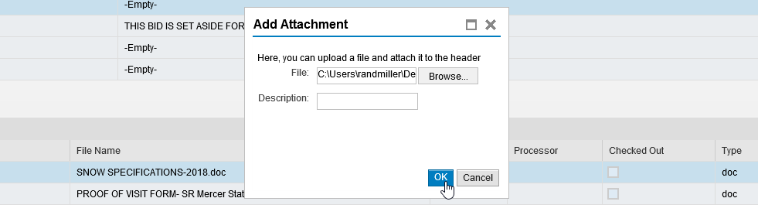
- Select the Items tab to enter line item prices. Prices should be entered in the Price column per unit of measure. Pressing Enter after each price will update the Total Value amount at the bottom right. If there are more than 10 total line items, scroll down to complete them all. If a price sheet was completed as an attachment, skip this step.
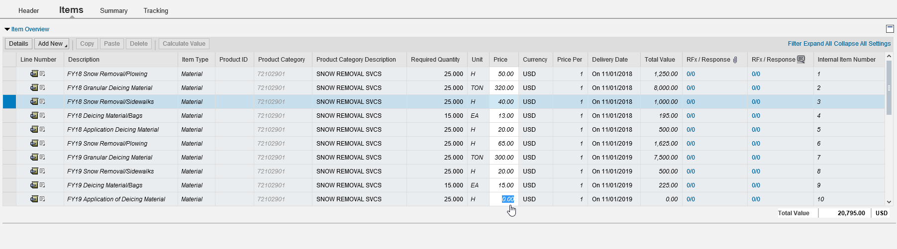
- Before submitting your response, select the Summary tab (see below) to review. Ensure that all applicable steps have been completed: all Items are responded to (if necessary), all Questions are answered (mandatory), all Notes and Attachments are included (if necessary), and the Total Response Value is accurate.
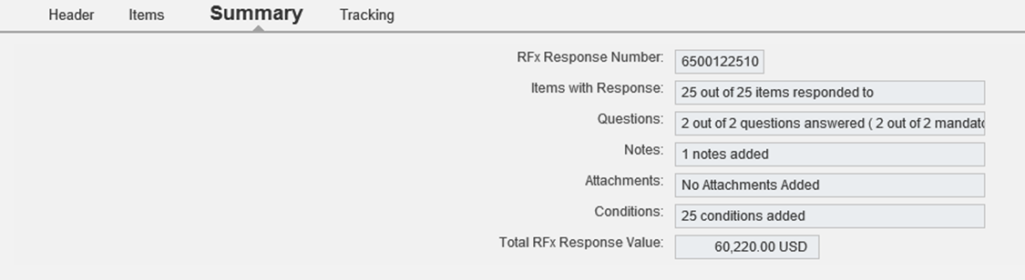
- When all information is correct, click the Check button at top. You will be prompted to submit the response.
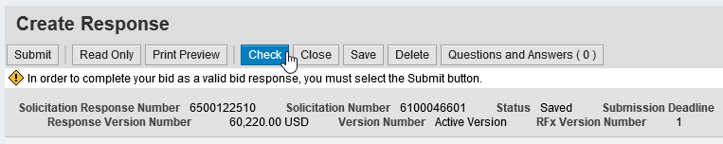
- Finally, click the Submit button. An approval message will appear below.
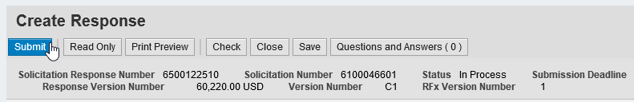

- If desired, a PDF copy of your bid can be viewed or saved by clicking the Print Preview button. Any attached documents will not be included. You do not need to print or mail this file.

- Close and Log Off to exit the PA Supplier Portal.
Saving a Solicitation Response
- To save a response, click the Save button at any time when working on it. Please note that this will simply “freeze” the response until you are ready to resume work.
- When ready to resume work, click the Edit button to pick up where you left off. If you have logged off between sessions, open the Response Number link to find the Edit button.

Editing or Withdrawing a Response
- To edit your response after submitting, open the Response Number link and click the Edit button. Make any desired changes and click the Check and Submit buttons as before. Your new response will overwrite the previous one. This can be done an unlimited number of times before the bid deadline.

- To withdraw a submitted bid response, open the Response Number link and click the Withdraw button any time after submitting. If desired, a withdrawn bid can still be re-submitted by clicking the Re-Submit Bid button on the same menu.

Any additional questions about locating or responding to PA Supplier Portal Solicitations can be directed to the Help Desk at (877) 435-7363, Option #2.

